**Amendment in Salesforce CPQ**

Salesforce CPQ is built to track the subscriptions of all your accounts automatically. So when a customer calls to make a change to their service, CPQ knows what they already have, so you can use that information to quickly create an amendment quote. Salesforce CPQ makes it easy to amend contracts to handle the most common scenarios.

* Increase or decrease quantity
* Add new subscription product
* Cancel before the subscription end date (early termination)
* Cancel and replace

However, you want to amend a contract, Salesforce CPQ manages all of the recordkeeping, so that your sales reps can focus on closing deals instead of entering data.

**Amendment in Contract Base Renewal Model**

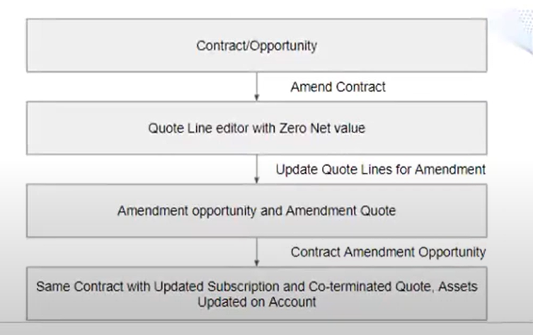

**Terminate a subscription**

To terminate a subscription, reduce the quantity of the related quote line to zero on your amendment quote. When you contract the opportunity containing that quote, Salesforce CPQ sets the Terminated Date value of the new subscription record to one day before the amendment quote's start date.

When you amend a contract containing terminated subscriptions, the amendment quote doesn't contain lines for the terminated subscriptions.

**Amendment on Asset based Renewal Model** –

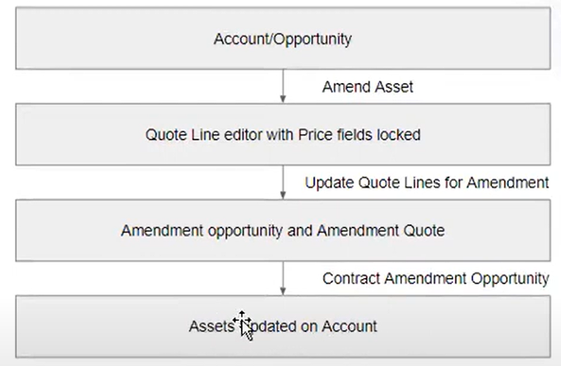

**Asset Upgrades and Downgrades**

The asset upgrades and downgrades features let your sales reps replace an asset with a different asset from within the quote line editor. This feature is useful for processing upgrades.

I Phone 14 : 1000 USD

iPhone 14 to iPhone 15 : 1500 USD

I Phone 15 : 2500 USD

I Phone 16: 3000 USD  
iPhone 14 to iPhone 16 : 2500 USD

**Interview Questions**:

1. Can we delete a product from renewal quote?
2. Can we delete a product from amendment quote?
3. Can you describe the differences between Amendment Quotes and Renewal Quotes in Salesforce CPQ?